

Circuit Playground Express

*Demonstrating Electrical Flow*

In early versions of the MESA curriculum, we started by immediately creating simple circuits using the Circuit Playground Express, but discovered that students were having difficulty understanding how their projects worked because they were not familiar with how electrical flow works. Because of that, we now begin with a very simple electrical circuit using a battery to power an LED.

1. Battery-powered LED

Have the students wire up a 9v battery, a **(TODO: How many Ohms?)** resistor, and an LED. Note that the long leg of the LED must be connected to the + end of the battery; an LED is a diode (that's what the D stands for), which means it only allows electricity to flow through it in one direction.

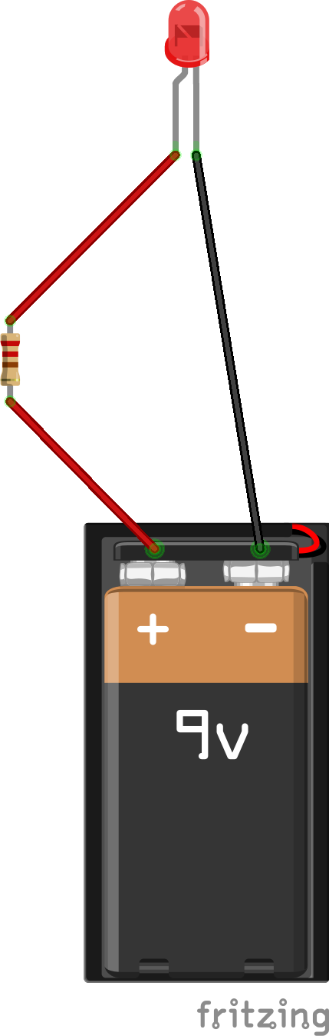

Ask your students why this circuit works? Why does the LED light up? The explanation is that electrical current is flowing through the wire, travelling from the + side of the battery to the - side, which we call the "ground." As the current passes through the LED, it activates it, causing it to emit light.

What is the resistor included in the circuit for? The simple answer is that it prevents the LED from exploding. The battery produces too much power for the LED to handle, and a resistor reduces the amount of power flowing through the circuit to a level that is safe for the LED.

2. Introducing the breadboard

Once students are comfortable with understanding how wires can convey electrical current from the + side of their battery to the - side, we can introduce the breadboard, which makes it easier to connect electrical components to each other.

Begin by explaining the structure of a breadboard, and which pins are connected to each other:

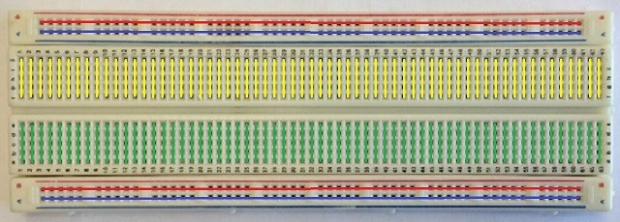

Why do we call these devices breadboards, anyway? Long ago, when people were prototyping electrical circuits, they would pound nails through an actual breadboard and tie their wires to the nails to connect up their circuits. Eventually, they developed these as a more convenient alternative, but the name stuck.

Now we can use a breadboard to wire up the same circuit as we had before. Note that you'll need to use wires with an alligator clip on one end (to attach to the battery) and a pin on the other (to insert into the breadboard's pinholes).

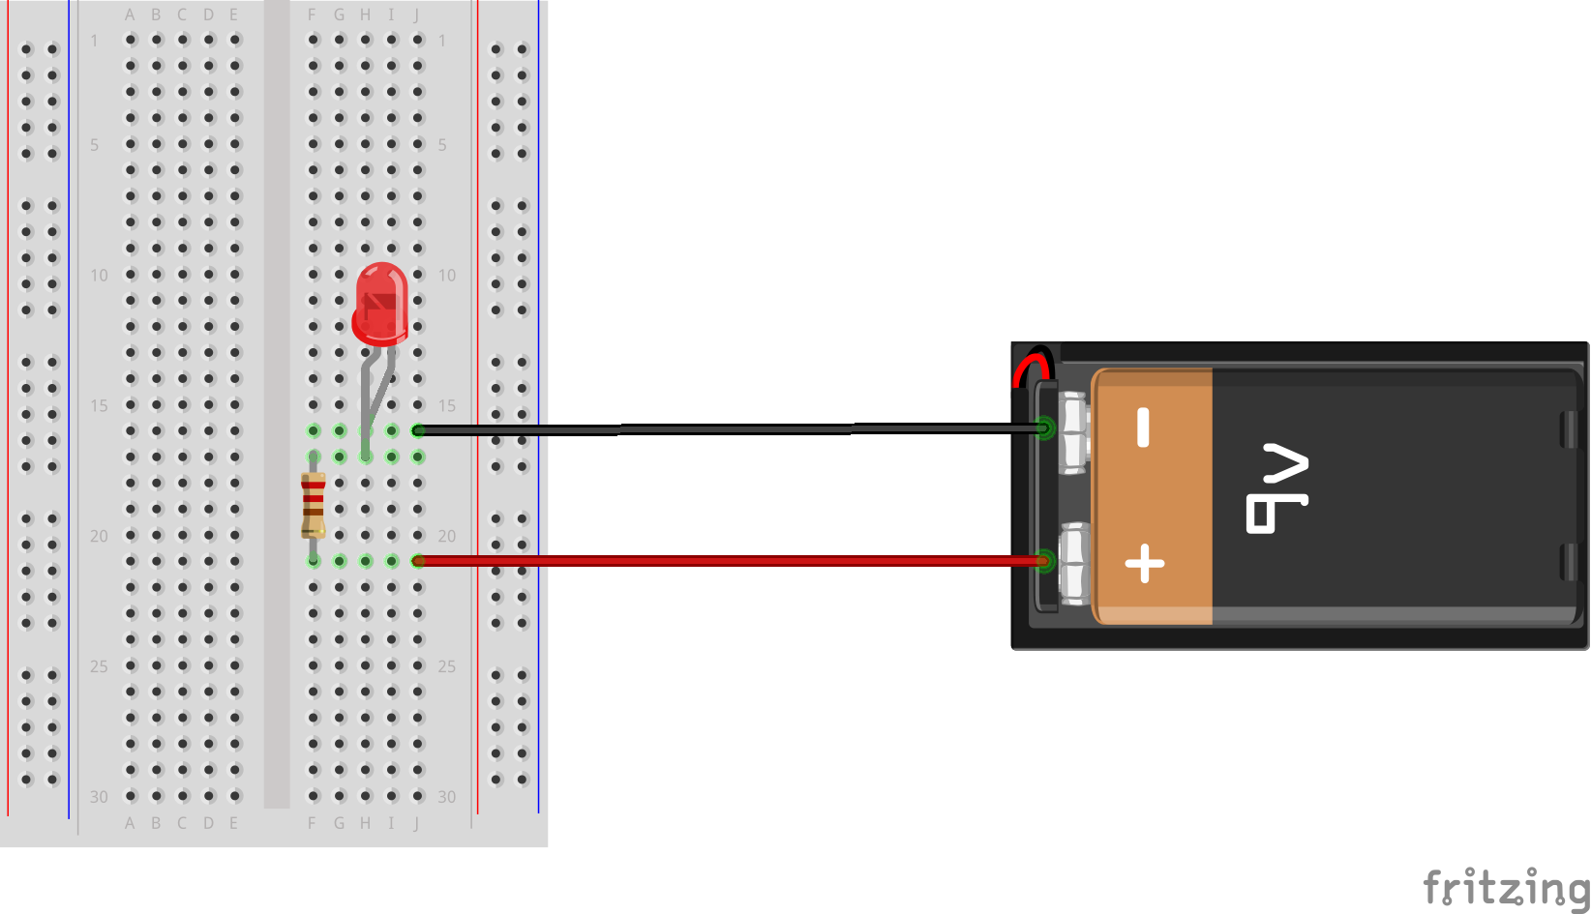

Because a breadboard is pretty unintuitive at first, it is a good idea to spend some time tracing the flow of electricity from the + side of the battery, through the breadboard row it is plugged into, through the resistor, and so on, so that your students can develop a strong grasp of the breadboard's role in the circuit. Our experience is that one of students' biggest struggles in troubleshooting their projects later on is a lack of understanding of how electricity is meant to flow through their circuits, so it is worth spending some time here to make sure their understanding is solid.

3. A button

The Circuit Playground Express has its own buttons that are very easy to write code for, and we will begin using them very soon. However, it is also possible to use an off-board button as part of an electrical circuit, which works by interrupting the circuit so that no electricity can flow through it unless it is pressed.

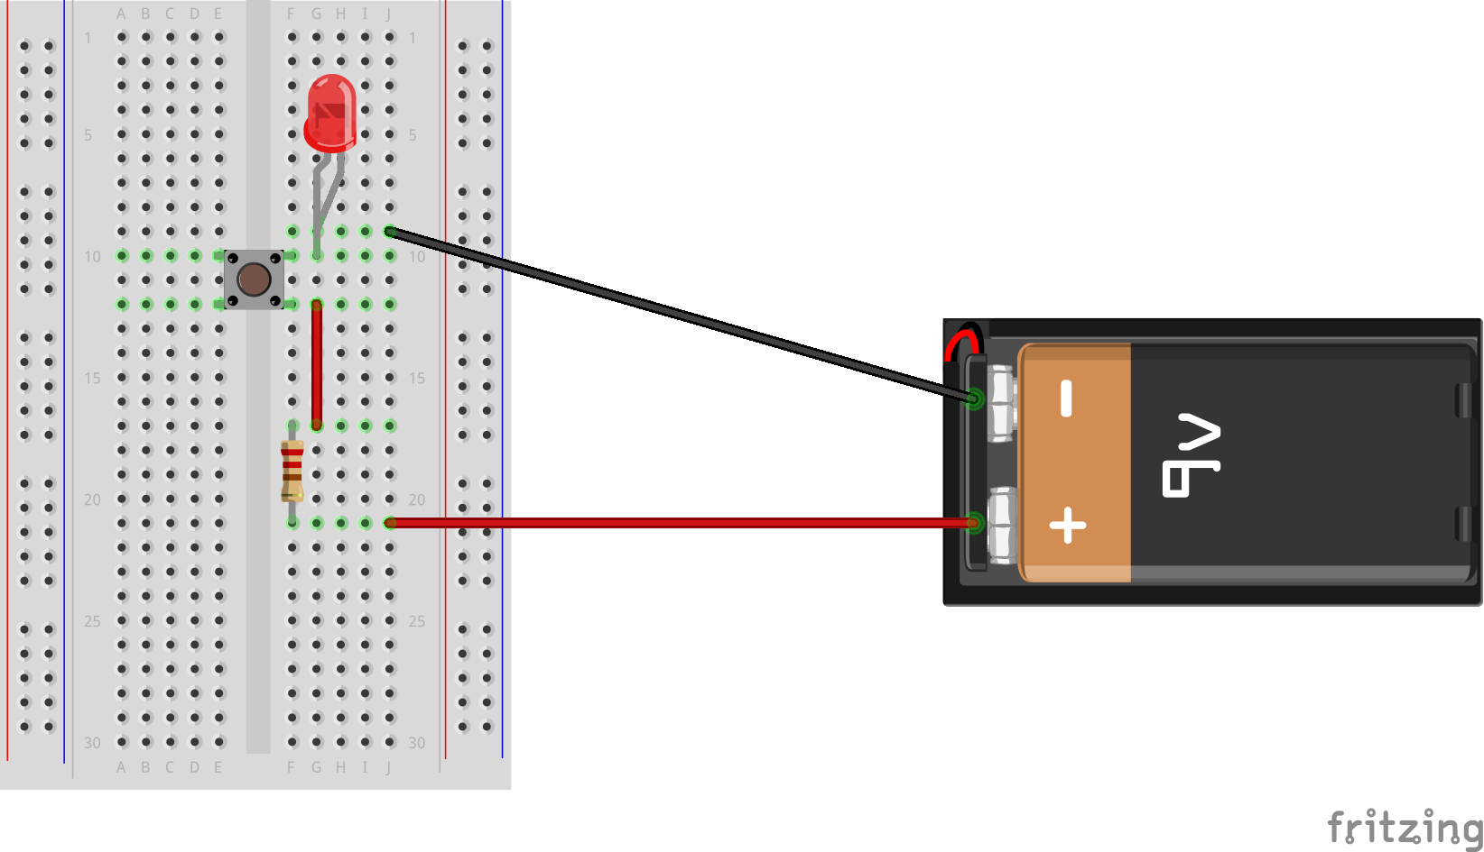

The above schematic shows how you can add a button to the previous circuit, so that the LED will only light up when the button is pressed. The reason this works is that the button is constructed to only allow current to flow through it when it is pressed.